

(All rights reserved)

**Interns**: Evans Acheampong and Josiah Lansah

**Course of study**: Computer Engineering and Computer Science

# **Instructor:** Douglas T. Ayitey

# **Date:** October 24th, 2022

**DAILY INTERNSHIP REPORT**

**DAY 6**

**PRATICAL MACHINE LEARNING PROJECTS WITH ARDUINO NANO BLE 33 SENSE**

* **GESTURE RECOGNITION USING ARDUINO NANO 33 BLE SENSE (THIRD PHASE)**
* **ADDED EMOJI BUTTONS (FIRST PHASE)**

**Introduction**

This report involves the addition of the emoji button to the gesture recognition project which was finalized in the former report as shown in the diagram below:

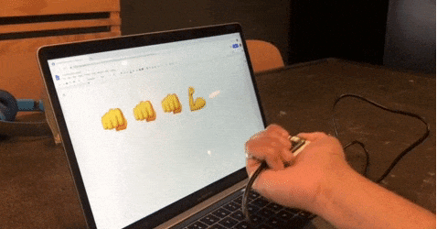

**Hardware and Software Required**

* An [Arduino Nano 33 BLE Sense](https://store.arduino.cc/nano-33-ble-sense) board
* A Micro USB cable to connect the Arduino board to your desktop machine
* To program the board, we used the [Arduino IDE](https://www.arduino.cc/en/main/software).
* Ubuntu
* Virtual Machine Ware

**Goals and Objectives**

* For added fun the [Emoji_Button.ino](https://github.com/arduino/ArduinoTensorFlowLiteTutorials/blob/master/GestureToEmoji/ArduinoSketches/Emoji_Button/Emoji_Button.ino) example shows how to create a USB keyboard that prints an emoji character in Linux and macOS. We tried combining the [Emoji_Button.ino](https://github.com/arduino/ArduinoTensorFlowLiteTutorials/blob/master/GestureToEmoji/ArduinoSketches/Emoji_Button/Emoji_Button.ino) example with the [IMU_Classifier.ino](https://github.com/arduino/ArduinoTensorFlowLiteTutorials/blob/master/GestureToEmoji/ArduinoSketches/IMU_Classifier/IMU_Classifier.ino) sketch to create a gesture controlled emoji keyboard.
* The code used is given as shown below:
* /*
* Emoji Button
* This example sends an emoji character over USB HID when the button is pressed.
* Note: Only macOS and Linux as supported at this time, and the use of
* #define is generally discouraged in Arduino examples
* The circuit:
* - Arduino Nano 33 BLE or Arduino Nano 33 BLE Sense board.
* - Button connected to pin 3 and GND.
* Created by Don Coleman, Sandeep Mistry
* This example code is in the public domain.
* */
* #include <PluggableUSBHID.h>
* #include <USBKeyboard.h>
* // Select an OS:
* //#define MACOS // You'll need to enable and select the unicode keyboard: System Preferences -> Input Sources -> + -> Others -> Unicode Hex Input
* //#define LINUX
* #if !defined(MACOS) && !defined(LINUX)
* #error "Please select an OS!"
* #endif
* // use table: https://apps.timwhitlock.info/emoji/tables/unicode
* const int bicep = 0x1f4aa;
* const int punch = 0x1f44a;
* const int buttonPin = 3;
* USBKeyboard keyboard;
* int previousButtonState = HIGH;
* void setup() {
* pinMode(buttonPin, INPUT_PULLUP);
* }
* void loop() {
* int buttonState = digitalRead(buttonPin);
* if (buttonState != previousButtonState) {
* if (buttonState == LOW) {
* // pressed
* sentUtf8(bicep);
* } else {
* // released
* }
* previousButtonState = buttonState;
* }
* }
* void sentUtf8(unsigned long c) {
* String s;
* #if defined(MACOS)
* // https://apple.stackexchange.com/questions/183045/how-can-i-type-unicode-characters-without-using-the-mouse
* s = String(utf8ToUtf16(c), HEX);
* for (int i = 0; i < s.length(); i++) {
* keyboard.key_code(s[i], KEY_ALT);
* }
* #elif defined(LINUX)
* s = String(c, HEX);
* keyboard.key_code('u', KEY_CTRL | KEY_SHIFT);
* for (int i = 0; i < s.length(); i++) {
* keyboard.key_code(s[i]);
* }
* #endif
* keyboard.key_code(' ');
* }
* // based on https://stackoverflow.com/a/6240819/2020087
* unsigned long utf8ToUtf16(unsigned long in) {
* unsigned long result;
* in -= 0x10000;
* result |= (in & 0x3ff);
* result |= (in << 6) & 0x03ff0000;
* result |= 0xd800dc00;
* return result;
* }

**Project Setbacks**

* In order to add the emoji button to the project using the code above, a Linux or macOS is required. This therefore counted as a major setback especially due to the fact that we were mostly limited to Windows Operating systems.

**Possible Solutions**

* Using a Linux based operating system.

In order to use a Linux OS, Ubuntu was obtained from the Microsoft Store.

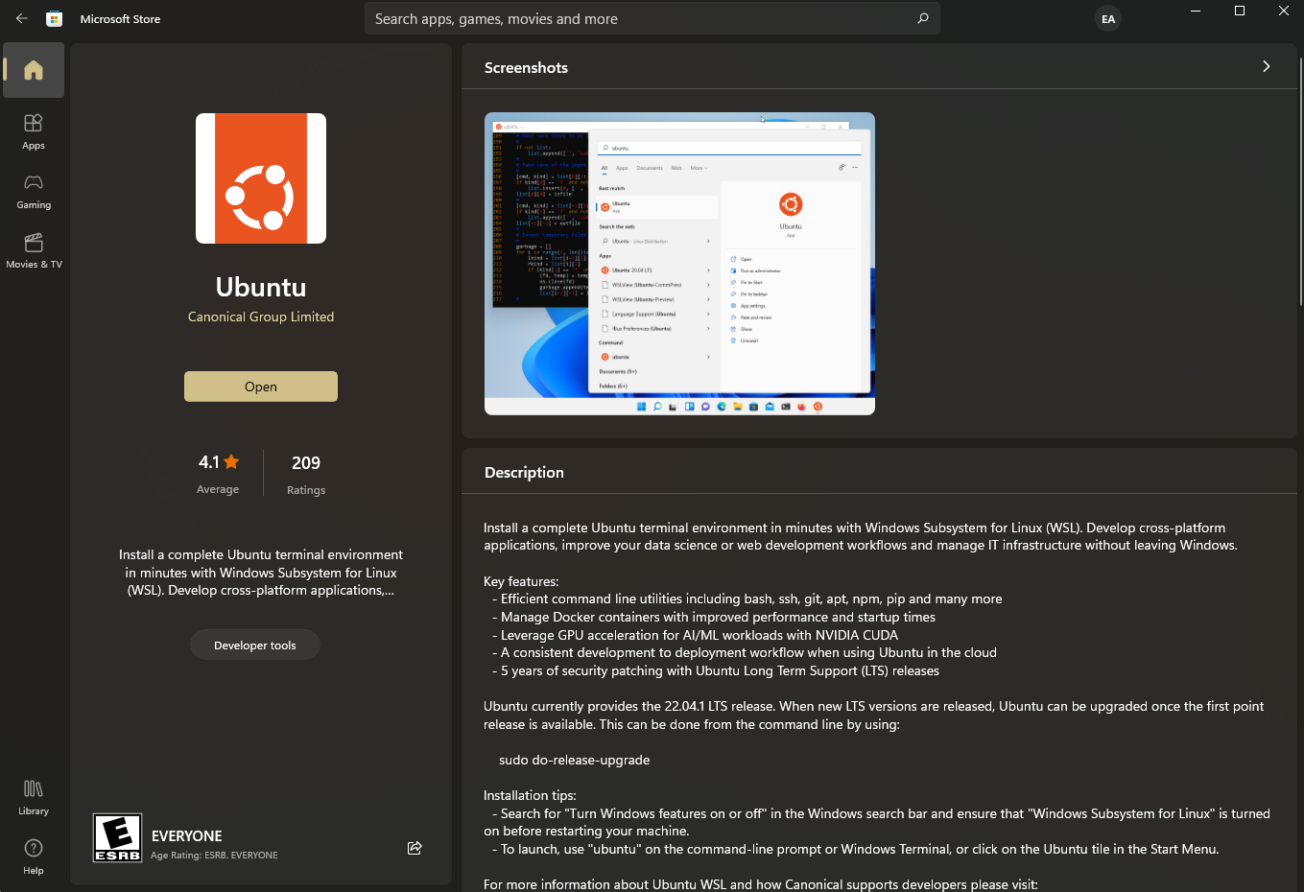

**Procedure**

* Import the [Emoji_Button.ino](https://github.com/arduino/ArduinoTensorFlowLiteTutorials/blob/master/GestureToEmoji/ArduinoSketches/Emoji_Button/Emoji_Button.ino) into the code alongside the IMU Classifier and model.h code in the Arduino IDE.

**Project Setbacks and Errors**

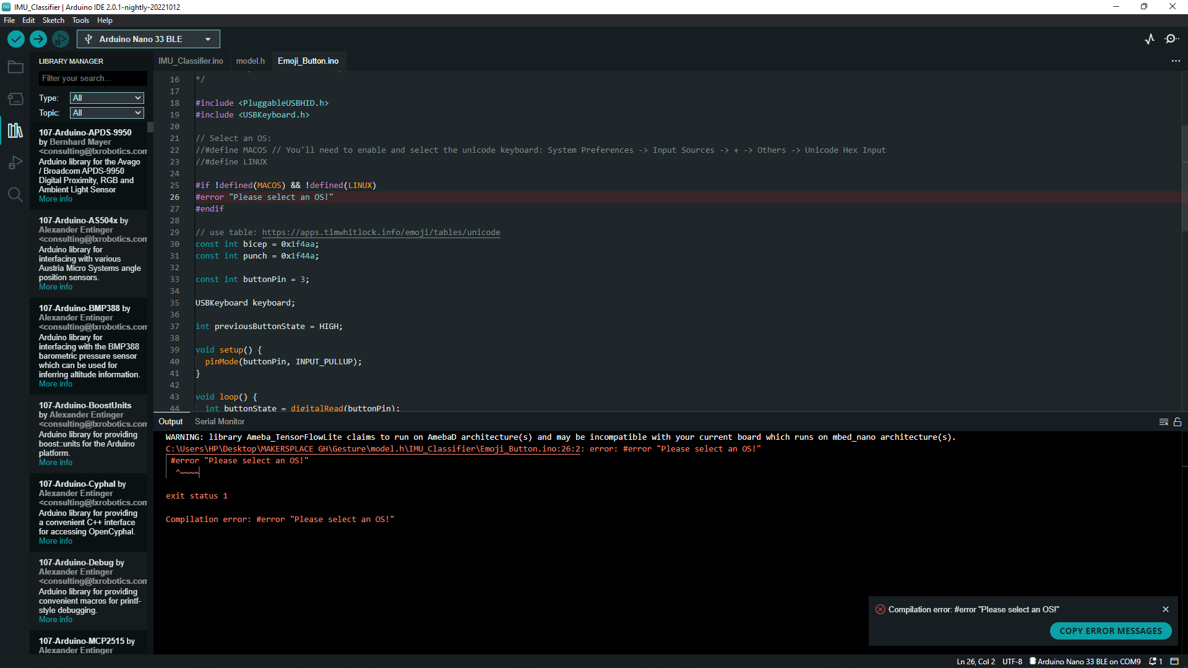

* After the installation of Ubuntu 20.04, an error was encountered as shown above.

Error: "Please select an OS!"

* Possible Solutions

Using VM Ware

## After installing and setting up the Virtual Machine Ware, we managed to create and **Install Ubuntu Linux On VMWare Workstation as shown below:**

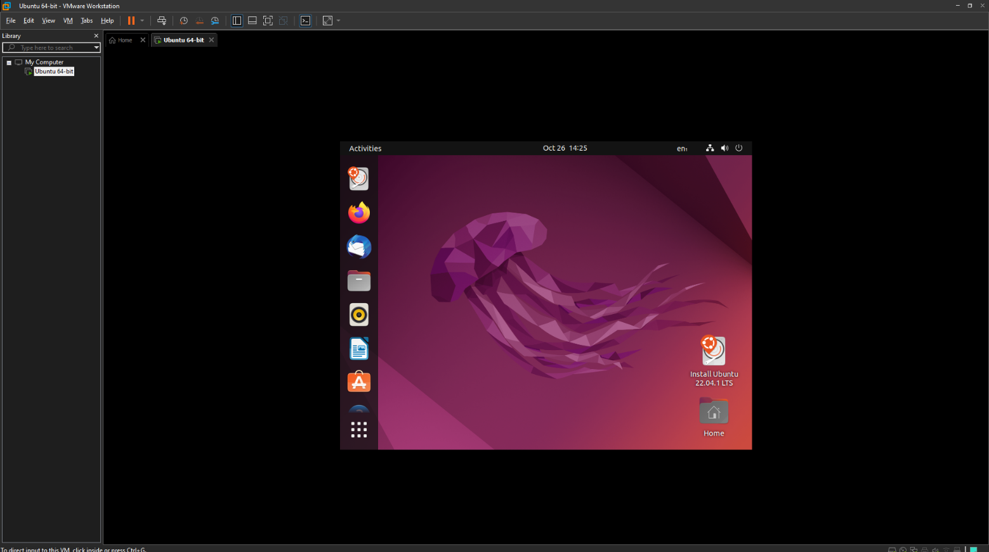

**Project Setbacks**

After hours of working with the ubuntu interface on VM Ware, we encountered several setbacks and errors:

* Since the Linux OS is running on a virtual machine, it is very slow, laggy and thus requires lots of time and effort.
* Downloading and running the Arduino ide on virtual machine takes a considerable amount of time and effort due to low memory allocation.
* Compilation several lines of code using the Arduino ide on a virtual machine is a very slow and time-consuming process which may result in errors.

**Possible Solutions**

After careful consideration of the factors above, we decided to make use of another platform –

Mac OS. Due to its high speed and readability, The Macintosh would be an appropriate alternative to Ubuntu which was initially run on a virtual platform.

NOTE: It must be well noted that this does not entail the entire the added feature of Emoji recognition project but about the first phase of it. The finalization of this project is detailed in the document of October 26th - DAY 7(Week 3).

**References**

[1] <https://blog.arduino.cc/2019/10/15/get-started-with-machine-learning-on-arduino/>

[2]<https://github.com/arduino/ArduinoTensorFlowLiteTutorials/blob/master/GestureToEmoji/ArduinoSketches/Emoji_Button/Emoji_Button.ino>

[3] <https://blog.tensorflow.org/2019/11/how-to-get-started-with-machine.html>

[4] <https://thesecmaster.com/install-ubuntu-linux-on-vmware-workstation/>